Assignment 2: Who is more likely to exercise? Due Sunday, Feb 15
GLBL 5021 Applied Methods of Analysis II

Learning goals:
- able to conduct an LPM, logit, and probit regression
- able to interpret the results from LPM, logit, and probit regression
- To get better, we need continued practice: data cleaning, creating variables, graphing!
Question of interest: Studies have shown that exercise can lead to various health benefits. Using the SHARE data from wave 4 (2011), who is more likely to exercise among older adults? This descriptive analysis can shed light on whether certain groups may face difficulty in exercising due to differences in preferences or other barriers.
Download “HW2_health_start” code from canvas in your preferred language. The code provides you with a start and some example codes to help you. Continue the code while following the instructions below. Once you finish your code, copy and paste it at the end of your submission. Submit the pdf of your assignment on Gradescope (canvas).
Part I: Investigating the data, sample selection, and creating key variables
Run the start of the code from “HW2_health_start”. The data comes from SHARE wave 4. You can view the complete questionnaire of the data here. For this assignment, we will only focus on a few variables: exercise (br015), age, female, bmi, married, income_pct_w4 (income decile), and eduyears_mod.
Below are labels for br015 and marital status.

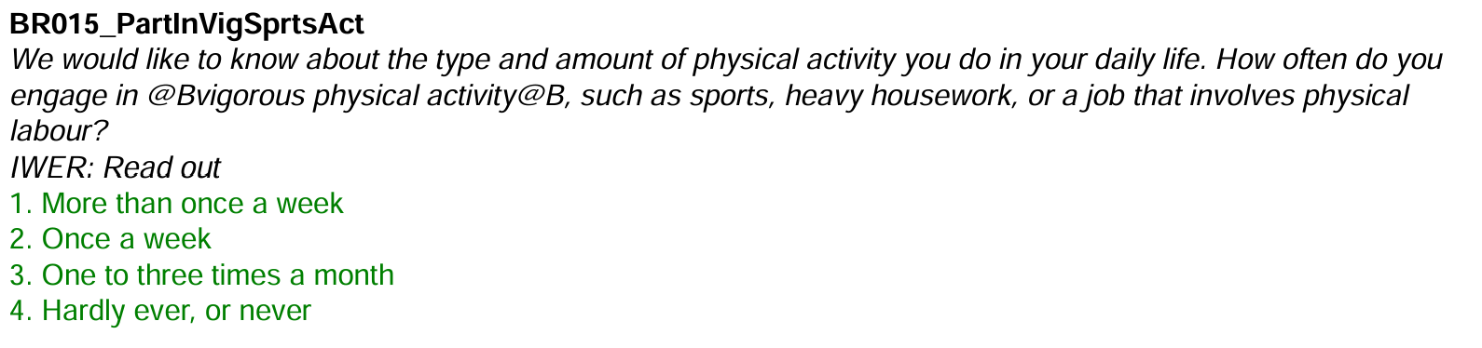
  - Use the exploration commands provided to check some of the variables above. You will notice that there are some negative values for some of the variables. These negative values identify data that is missing. Filter the data so that you work with observations with positive values only.

  - Let’s create some key variables. First, create a binary variable “exercise”. You can choose a level of exercise that you deemed appropriate. Provide an explanation for your choice below and report the % of people in your sample who do exercise based on your definition.
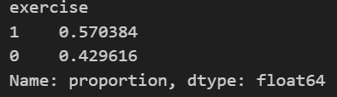
I have defined excercising as engaging in a physical activity at least once a week. One or to three times a month is not enough and could include people who just take a brisk walk to the grocery shop. Per this definition, approximately 57% of the people in the sample exercise.
  - Now create a variable “married” defined as either married or registered partnership.

Part II: Run an LPM model and provide some interpretation.
Let’s start with simpler regressions and practice interpreting them.
2.1 Before running a regression, you want to investigate whether you would like to create spline variables or polynomials. Draw four lowess graphs with “exercise” in the y-axis and (i) years of education, (ii) age, (iii) bmi, and (iv) income decile. Report the graphs below.
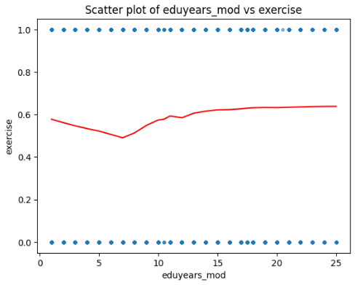
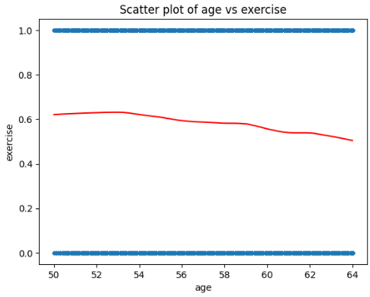
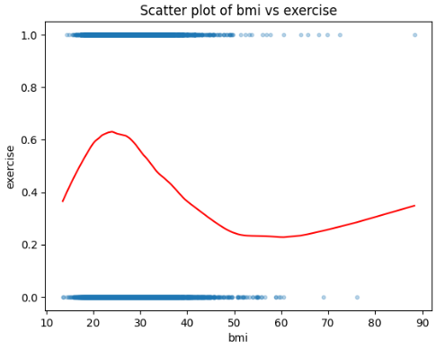
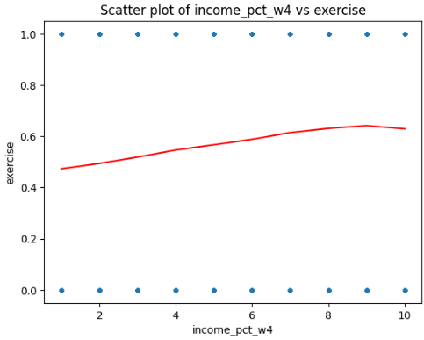
2.2 Decide which variable(s) you would like to create a spline for. At least 2 variables should be done using a spline. Provide an explanation for your choice of spline and others based on the graphs above.
I have decided to create splines for BMI, income, and years of education, as for these variables, the graphs show possible non-linearity. I have chosen to create the splines at points where the lowess curve takes a turn from being positive to negative or vice versa (ecuation, income, bmi) or in the middle of curves which have too much of a curvature (education).
2.3 Run three types of regressions: (1) exercise on female and age (2) exercise on all key variables, and (3) exercise on all key variables + dummy variables for each country.
Key variables: age, female, bmi, married, income_pct_w4 (income decile), and eduyears_mod. Make sure you use the transformed variables from part 2.2.
Report the results here (you do not need to show the countries’ results.
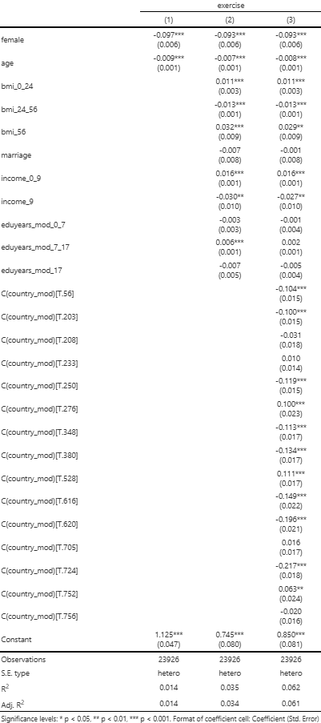
2.4 Provide an interpretation for the coefficient on female, a continuous variable, and one of your spline variables from the previous table. Interpret the coefficient only. A deeper analysis of the results will be asked in the next question.
In model 1, the coefficient on female is -0.097 whilst for models 2 and 3, it's -0.093 (all significant at p<0.001). For model 1, this means that females (holding all else constant) are 9.7% less likely to exercise than men. For models 2 and 3, that difference in probabilities is 9.3%.
In models 1, 2, and 3, the coefficients on age are -0.009, -0.007, and -0.008 respectively (all significant at p<0.001). This means that as one gets older by a year, their predicted chance of exercising (holding all else constant) decrease by 0.9%, 0.7%, and 0.8%, respectively per the relevant model.
In models 2 and 3, the coefficients on bmi_0_24 are 0.011 (both significant at p<0.001). This means that as one increases their BMI by 1, their predicted chance of exercising (holding all else constant) increases by 1.1%, if their BMI is between 0 (not inclusive) and 24 (inclusive). The coefficients on bmi_24_56 are -0.013 (both significant at p<0.001). This means that as one increases their BMI by 1, their predicted chance of exercising (holding all else constant) decreases by 1.3%, if their BMI is between 24 (not inclusive) and 24 (inclusive). The coefficients on bmi_56 are 0.032 and 0.029 respectively (one significant at p<0.001 and the other at p<0.01). This means that as one increases their BMI by 1, their predicted chance of exercising (holding all else constant) increases by 3.2% and 2.9% respectively, if their BMI is above 56.
2.5 Based on the LPM above, provide three interesting insights on who tends to exercise more?
It appears that men tend to exercise more (or at least declare that they do so). This could be explained by differences in declaration (men might be more prone to label more activities as exercise (such as work around the house etc.)). It could also be explained by a larger portion of men in blue collar jobs.
It is interesting to see that education does not appear to have much influence on exercising besides the spline eduyears_mod_7_17 (but even there, the effects are low even with strong significance). This might be because we don't have enough observations in the other two splines. The small effect in 7_17 might be explained that as one becomes more educated, they become more aware of the health effects of a sedentary lifestyle. Thus, some people become motivated to move at least once a week.
For BMI, the biggest surprise lies in the spline bmi_56. People with a BMI above 56 are morbidly obese, so one would imagine almost no exercise compared to people with lower BMIs. However, it might be thas as people increase their BMI in the above56 spline, their health is so bad that they become forced by their caretakers to move at least a bit to minimise the negative effects on their health.Graph and/or written answers required.
2.6 Run the second regression (from question 2.3) with no spline variables at all. Then compare it with the regression where there are spline variables. Provide the results below and explain whether you think you have made the right decisions with the splines.
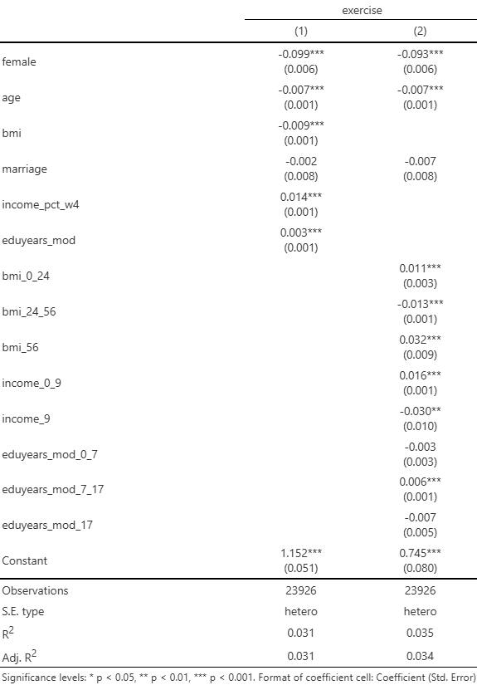
Using the splines was a correct decision. The $R^2$ increases slightly. We also get a glimpse into the interval of education that makes the biggest difference (between 7 and 17 years) compared to the others that are not statisticall significant.
Part III: Comparing LPM, logits, and probit
3.1 For the second LPM model (without controlling for countries), run a logit and probit model, as well as the marginal effects. Provide the coefficients and marginal effects below (with the original LPM).
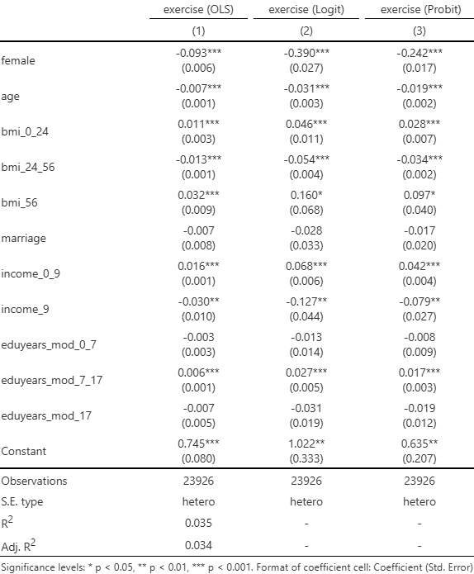
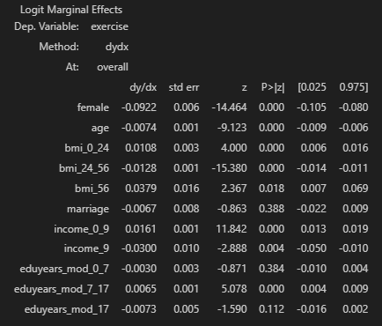
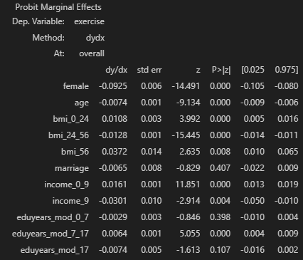
3.2 Explain how different the results of your three models are and whether you prefer one over the others.
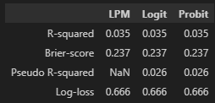
It seems that there is no significant difference between the models when it comes to explanatory power.

